TERRAFORM CHALLENGE

Create an EC2 Instance on AWS Cloud using the below-mentioned ubuntu AMI and instance_type. Or, (You can use of your choice as well) ami = "" instance_type = "t3.micro"
Write the terraform code to create a security group and lauch an instance using that security group
provider "aws" {
region = "us-east-1"
}

resource "aws_security_group" "web_sg" {
name = "web-server-sg"
description = "Allow HTTP traffic on port 8080"

ingress {
from_port = 8080
to_port = 8080
protocol = "tcp"
cidr_blocks = ["0.0.0.0/0"]
}

egress {
from_port = 0
to_port = 0
protocol = "-1"
cidr_blocks = ["0.0.0.0/0"]
}
}

resource "aws_instance" "web" {
ami = "ami-0ecb62995f68bb549" # your ubuntu AMI
instance_type = "t3.micro"
subnet_id = "subnet-0491ca8b1885b7e5e"
vpc_security_group_ids = [aws_security_group.web_sg.id]

user_data = <<-EOF
#!/bin/bash
apt update -y
apt install -y nginx
sed -i 's/listen 80 default_server/listen 8080 default_server/' /etc/nginx/sites-available/default
systemctl restart nginx
EOF

tags = {
Name = "terraform-web-server"
}
}
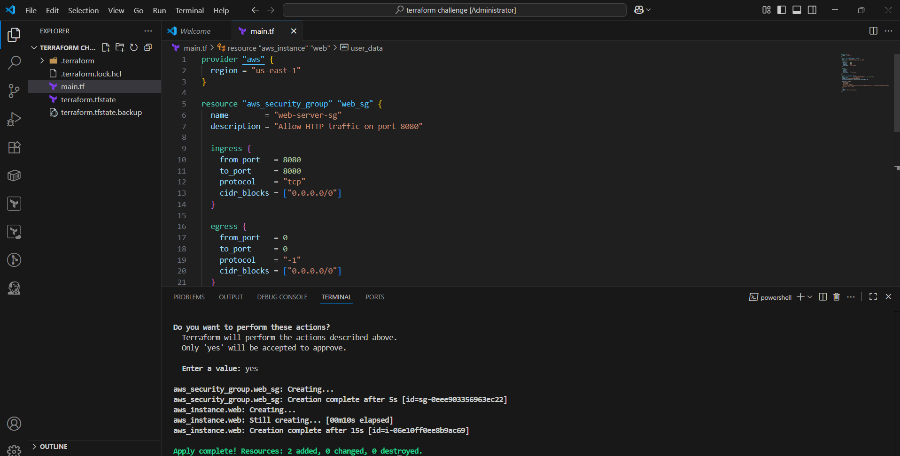
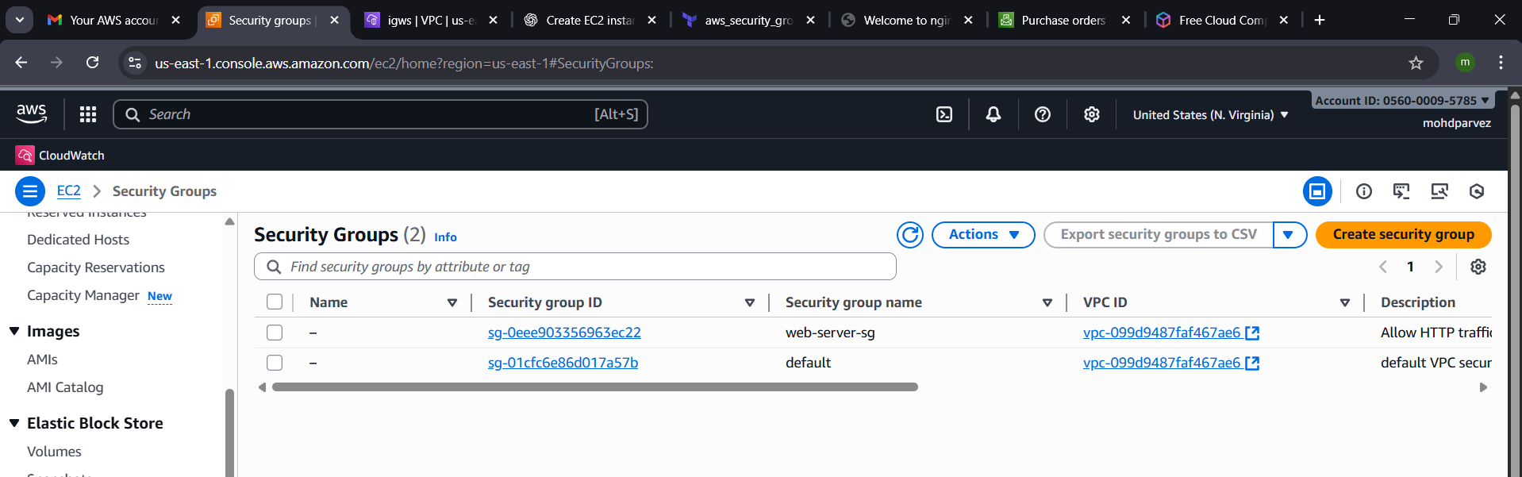
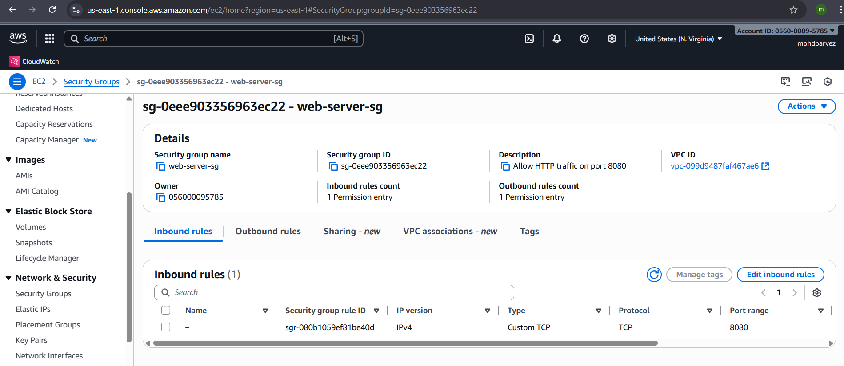
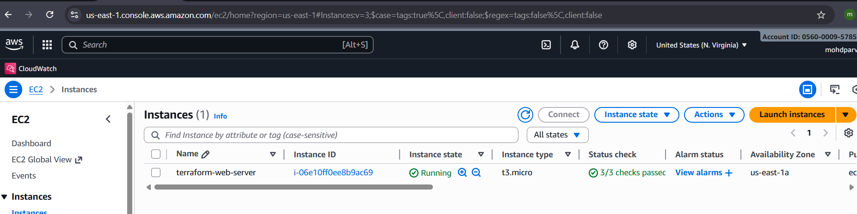

Install a web server on the same EC2 Instance. The web server should listen on port 8080.

Use the terraform resource block to launch an instance with web server installed and listen to port 8080
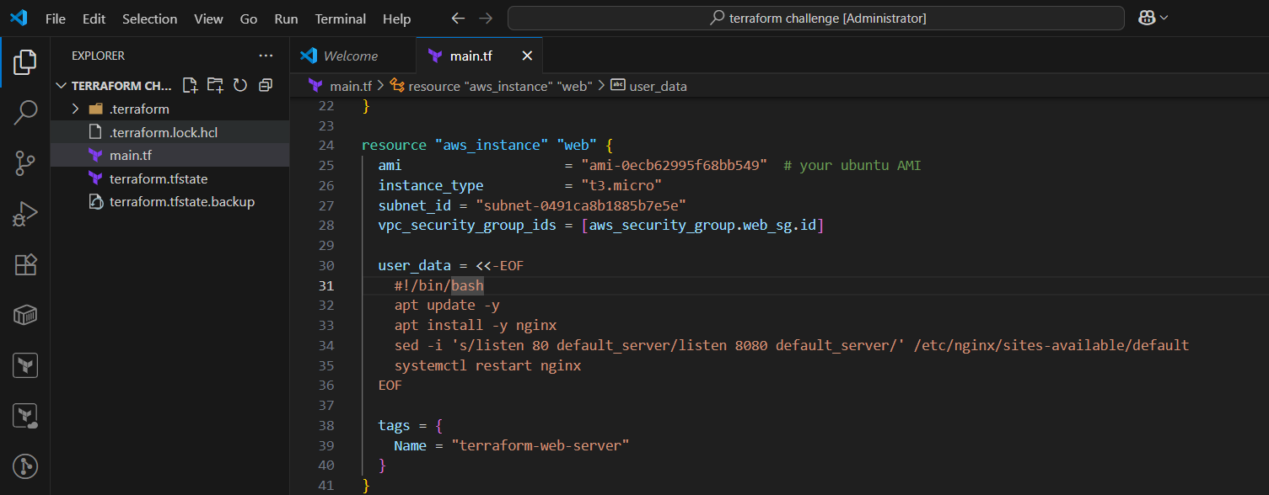
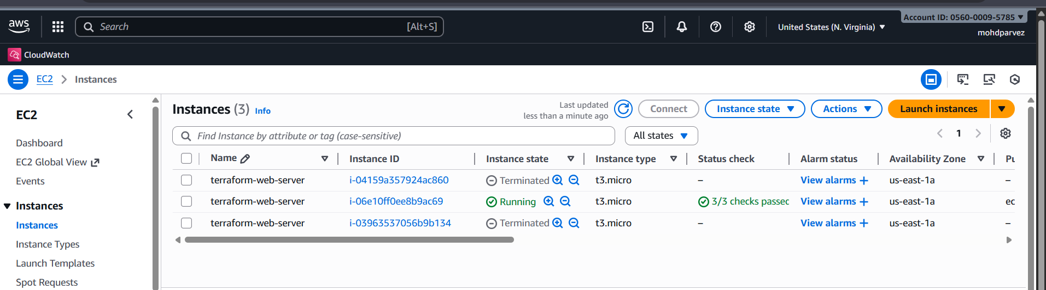
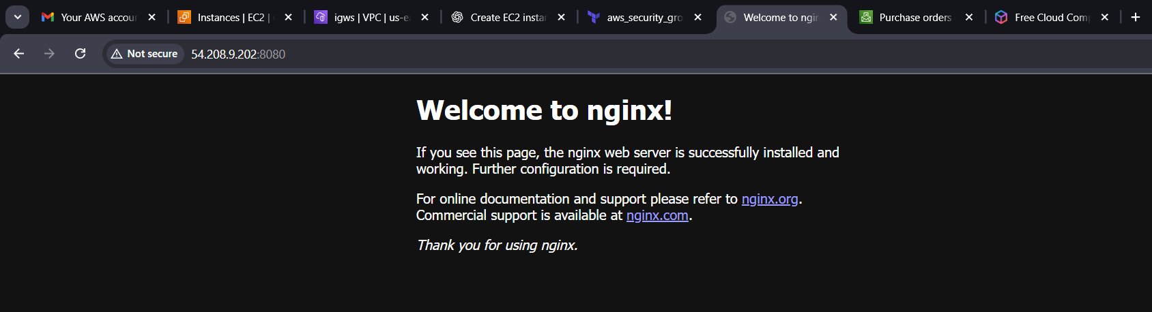
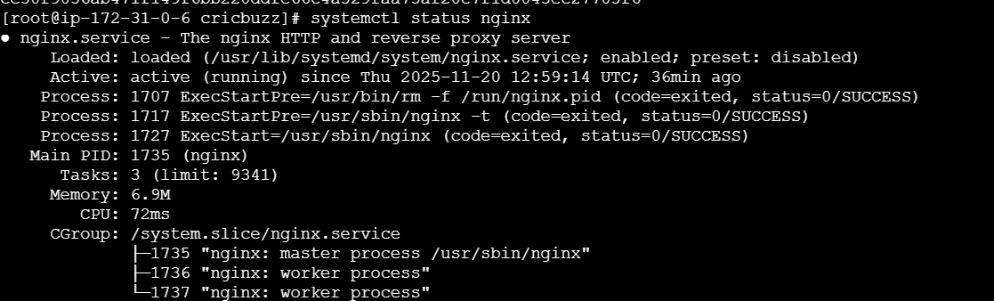

Create a Docker-compose file for the project: https://github.com/betawins/cricbuzz-docker-hello-world.git and point it to port 8000.
This will change the port number for nginx
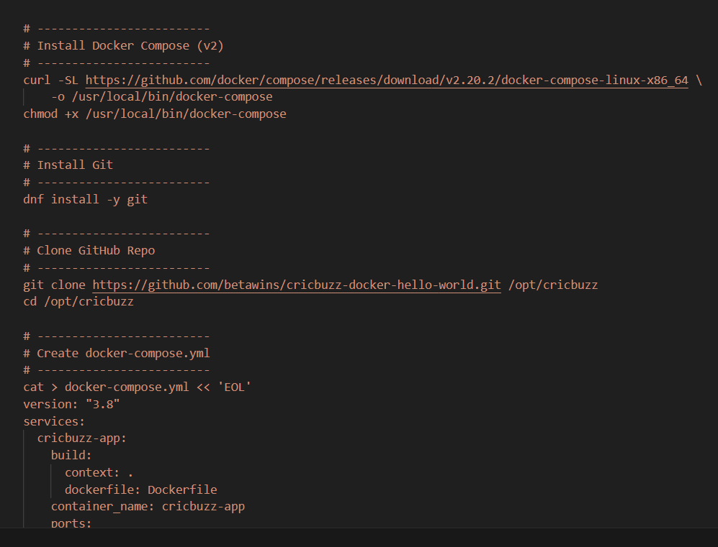
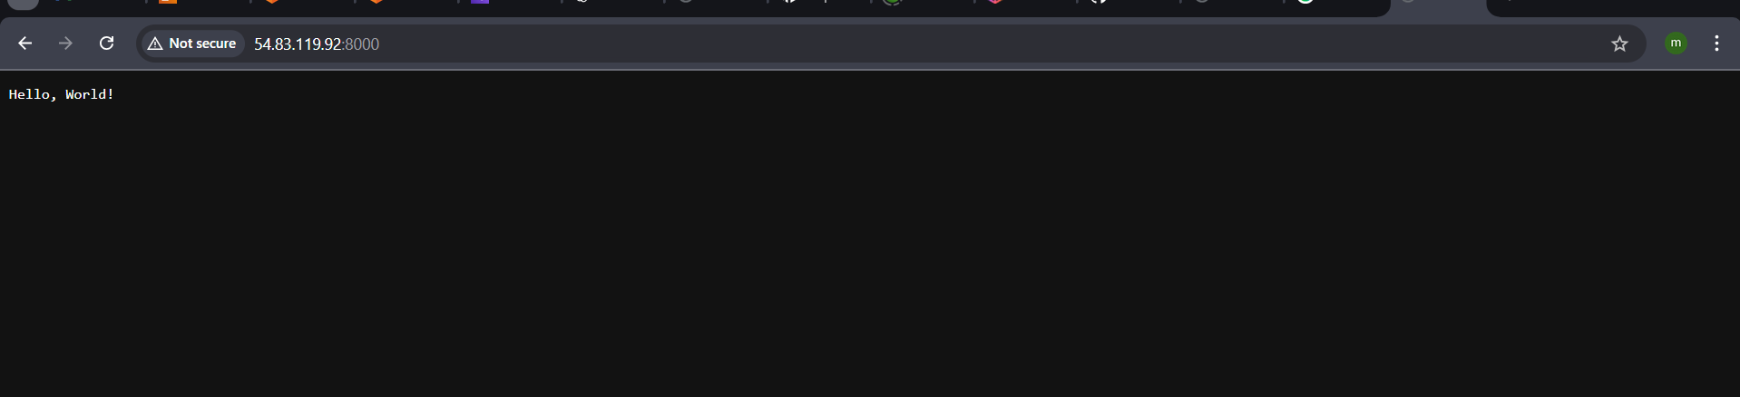

Make the web server point to the above service so that 8080 returns the response from the Docker service.
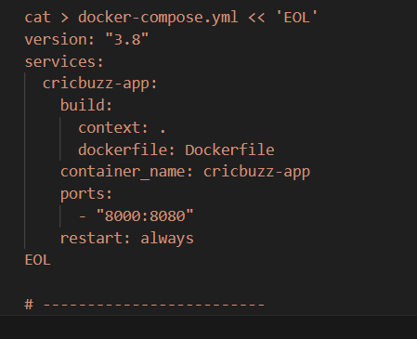
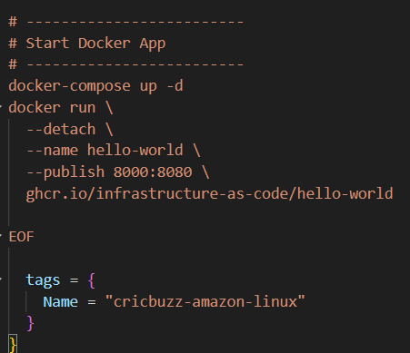
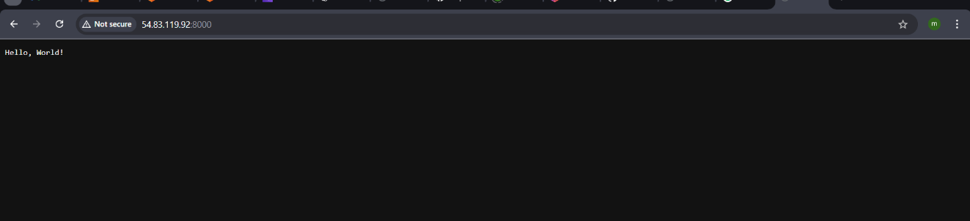

Configure to Save the Logs in the location /var/log/cb.log

Write the Log rotate configuration for the above file
